Question 1 : Linear regression with Batch Gradient Descent
Assignment 1: Solutions – Code with graphs
Jasvith Raj Basani – 2017A3TS0374H

%Preprocessing data
data = xlsread('data.xlsx'); %Read data from data.xlsx file
X = [ones(size(data, 1), 1) data(:, 1:2)]; %Feature vector
X(:, 2) = (X(:, 2) - mean(X(:, 2)))/std(X(:, 2)); %Normalize column 2 of feature vector
X(:, 3) = (X(:, 3) - mean(X(:, 3)))/std(X(:, 3)); %Normalize column 3 of feature vector
Y = data(:, 3); %Output vector
Y = (Y - mean(Y))/std(Y); %Normalizing output vector
w = [0 0 0]; %Initial weights
alpha = 0.001; %Alpha is the learning rate
iter_nos = 100; %Number of iterations
J = zeros(iter_nos+1, 1); %Array to store cost after each iteration
W = zeros(iter_nos+1, 2); %Array to store weights after each iteration
J(1) = evaluatecostfunction(X, Y, w);
W(1,1) = w(1);
W(1,2) = w(2);
for i = 1:1:iter_nos
H = (X*(w')) - Y; %Hypothesis Calculation
for j = 1:1:3
w(j) = w(j) - alpha*((H')*X(:, j)); %Weight Update
end
J(i+1) = evaluatecostfunction(X, Y, w);
W(i+1, 1) = w(2);
W(i+1, 2) = w(3);
end
x = 0:1:iter_nos;
plot(x, J);
w1 = 0.4:-0.001:-0.2;
w2 = 1:-0.005:-0.2;
J1 = zeros(length(w1), length(w2));
for i = 1:1:length(w1)
for j = 1:1:length(w2)
J1(i, j) = evaluatecostfunction(X, Y, [0 w1(i) w2(j)]); %Calculating cost function
end
end
figure;
plot3(W(:, 1), J, W(:, 2));
grid on;
figure;
contour(w2, w1, J1);
hold on;
plot(W(:, 2), W(:, 1));
function J = evaluatecostfunction(X, Y, W) %Function to evaluate cost function
J = 0;
for i = 1:1:size(X, 1)
J = J + (W*(X(i, :)') - Y(i))^2; %Cost function update formula
end
J = J/2;
end

Final Weights : [0.0000 0.0781 0.3606]

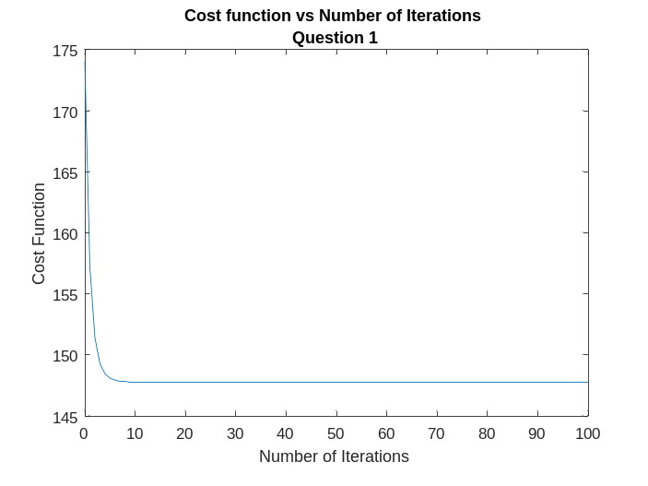
Outputs :

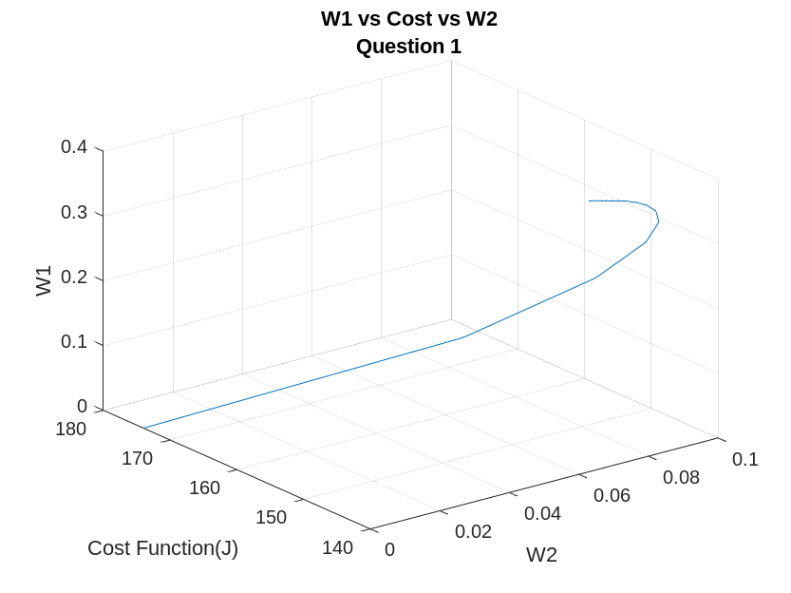

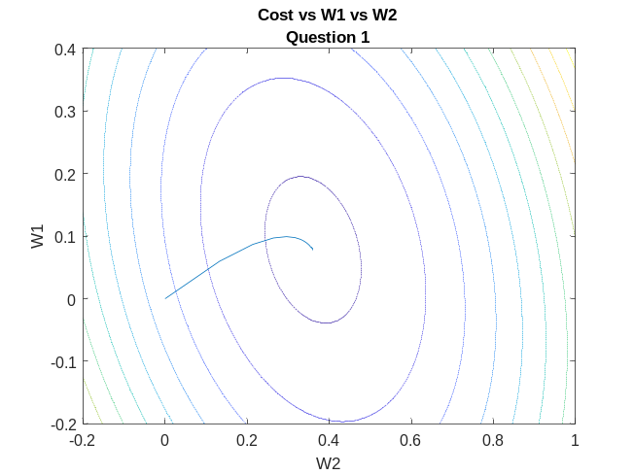

Question 2: Linear Regression – Stochastic Gradient Descent

%Preprocessing the data
data = xlsread('data.xlsx');
X = [ones(size(data, 1), 1) data(:, 1: 2)];
X(:, 2) = (X(:, 2) - mean(X(:, 2)))/(std(X(:, 2)));
X(:, 3) = (X(:, 3) - mean(X(:, 3)))/(std(X(:, 3)));
Y = data(:, 3);
Y = (Y - mean(Y))/(std(Y));
w = [0 0 0]; %Initialise the weights
alpha = 0.001; %Learning Rate
iter_nos = 100;
t_instances = 50; %Number of instances per iteration
J = zeros(iter_nos*t_instances + 1, 1); %Array for cost of each iteration
W = zeros(iter_nos*t_instances + 1, 3); %Array to store weigths after each iteration
J(1) = evaluatecostfunction(X, Y, w);
W(1,1) = w(1);
W(1,2) = w(2);
W(1,3) = w(3);
for i = 1:1:iter_nos
X_new = randperm(size(X, 1), t_instances);
for j = 1:1:t_instances
H = (X(X_new(j), :)*w') - Y(X_new(j)); %Hypothesis Calculation
for q = 1:1:3
w(q) = w(q) - alpha*(H*X(X_new(j), q)); %Weight Update Rule
W((i-1)*t_instances+j+1, q) = w(q);
end
J((i-1)*t_instances + j + 1) = evaluatecostfunction(X, Y, w);
end
end
x = 0:1:iter_nos*t_instances;
plot(x,J)
w1 = 0.4:-0.001:-0.2;
w2 = 0.8:-0.005:-0.2;
J1 = zeros(length(w1), length(w2));
for i = 1:1:length(w1)
for j = 1:1:length(w2)
J1(i, j) = evaluatecostfunction(X, Y, [0 w1(i) w2(j)]);
end
end

figure;
plot3(W(:, 2), W(:, 1), J)
grid on;
figure;
contour(w2, w1, J1);
hold on;
plot(W(:, 2), W(:, 1));
function J = evaluatecostfunction(X, Y, W) %Function to calculate the cost function
J = 0;
for i = 1:size(X, 1)
J = J + ((W*X(i,:)') - Y(i))^2;
end
J = J/2;
end
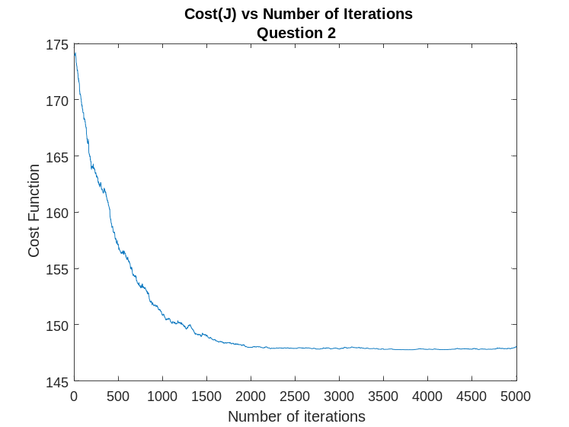
Final Weights : [-0.0018 0.0905 0.3580]
Outputs :

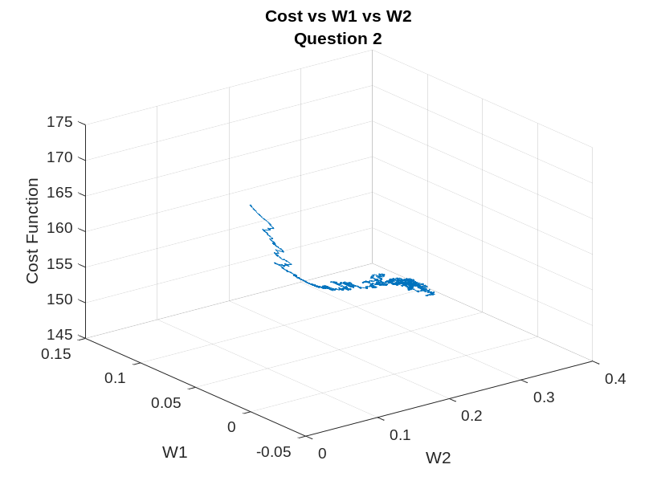

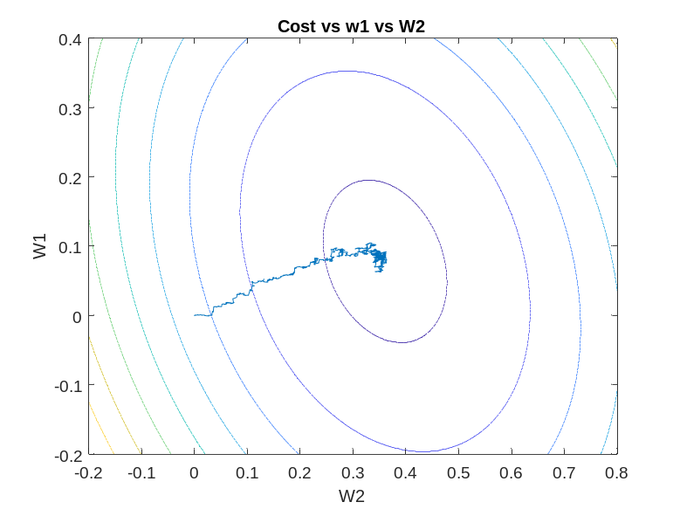

Question 3 – Ridge Regression with Batch Gradient Descent

%Preprocessing the data
data = xlsread('data.xlsx');
X = [ones(size(data, 1), 1) data(:, 1:2)];
X(:, 2) = (X(:,2) - mean(X(:, 2)))/std(X(:, 2));
X(:, 3) = (X(:, 3) - mean(X(:, 3)))/std(X(:, 3));
Y = data(:, 3);
Y = (Y - mean(Y))/std(Y);
w = [0 0 0]; %Initial Weigths
alpha = 0.001; %Learning rate
lambda = 0.4; %Regularization Parameter
iter_nos = 100;
J = zeros(iter_nos + 1, 1); %Array for cost of each iteration
W = zeros(iter_nos + 1, 2); %Array to store weights after iteration
J(1) = evaluatecostfunction(X, Y, w, lambda);%Initial Cost calculation
W(1, 1) = w(1);
W(1, 2) = w(2);
for i = 1:1:iter_nos
H = X*(w)' - Y; %Hypothesis calculation
for j = 1:1:3
w(j) = w(j) - alpha*(((H')*X(:, j)) - lambda*w(j));
end
J(i+1) = evaluatecostfunction(X, Y, w, lambda);
W(i+1, 1) = w(2);
W(i+1, 2) = w(3);
end
x = 0:1:iter_nos;
plot(x, J);
w1 = 0.4:-0.001:-0.2;
w2 = 0.8:-0.005:-0.2;
J1 = zeros(length(w1), length(w2));
for i = 1:1:length(w1)
for j = 1:1:length(w2)
J1(i, j) = evaluatecostfunction(X, Y, [0 w1(i) w2(j)], lambda);
end
end
figure;
plot3(W(:, 1), J, W(:, 2));
figure;
contour(w2, w1, J1);
hold on;
plot(W(:, 2), W(:, 1));
function J = evaluatecostfunction(X, Y, w, lambda) %Function to calculate the cost function of ridge regression
J = 0;
for i = 1:1:size(X, 1)
J = J + (w*(X(i, :))' - Y(i))^2;
end
J = J + lambda*sum(w.^2);
J = J/2;
end

Final Weights : [0.0000 0.0780 0.3610]
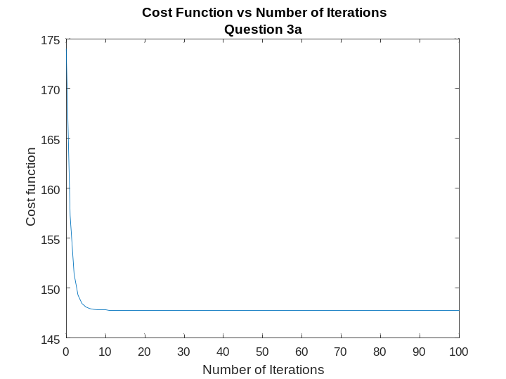
Outputs :

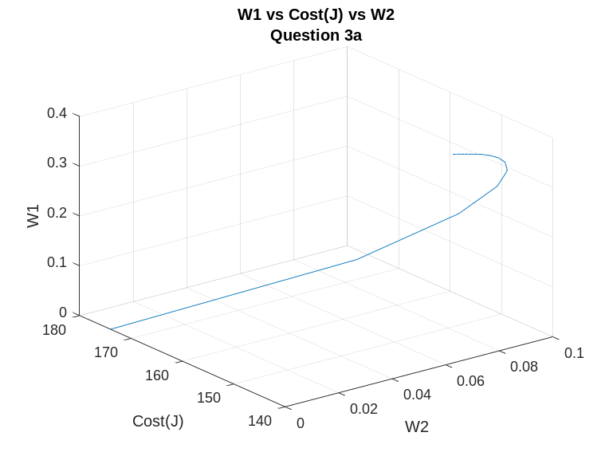

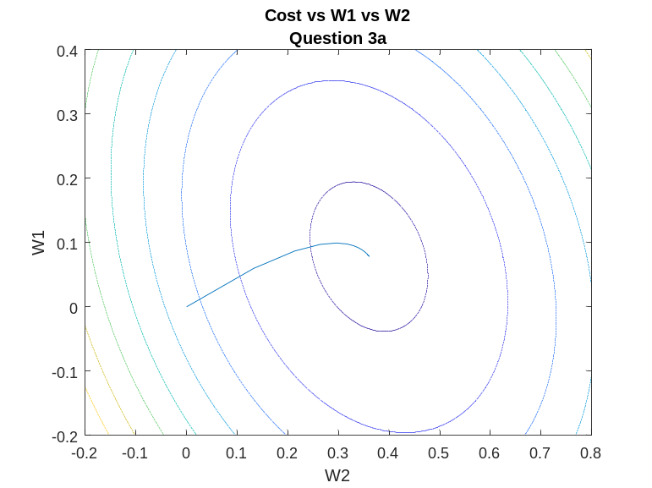

Question 3 – Ridge Regression – Stochastic Gradient Descent

%Preprocessing the data
data = xlsread('data.xlsx');
X = [ones(size(data, 1), 1) data(:, 1:2)];
X(:, 2) = (X(:, 2) - mean(X(:, 2)))/std(X(:, 2));
X(:, 3) = (X(:, 3) - mean(X(:, 3)))/std(X(:, 3));
Y = data(:, 3);
Y = (Y - mean(Y))/std(Y);
w = [0 0 0]; %Initializing the weights
alpha = 0.001; %Learning rate
lambda = 0.25; %Regularization parameter
iter_nos = 500;
t_instances = 50;
J = zeros(iter_nos*t_instances + 1, 1); %Array to store cost after every iteration
W = zeros(iter_nos*t_instances + 1, 2); %Array to store weights after every iteration
J(1) = evaluatecostfunction(X, Y, w, lambda);
W(1,1) = w(1);
W(1,2) = w(2);
W(1,3) = w(3);
for i = 1:1:iter_nos
X_new = randperm(size(X, 1), t_instances);
for j = 1:1:t_instances
H = X(X_new(j), :)*(w)' - Y(X_new(j));
for q = 1:1:3
w(q) = w(q) - alpha*((H')*(X(X_new(j), q)) - lambda*w(q)); %Weight update rule
W((i-1)*t_instances + j + 1,q) = w(q);
end
J((i-1)*t_instances+j+1) = evaluatecostfunction(X, Y, w, lambda);
end
end
x = 0:1:t_instances*iter_nos;
plot(x, J)
w1 = 0.4:-0.001:-0.2;
w2 = 0.8:-0.005:-0.2;
J1 = zeros(length(w1), length(w2));
for i = 1:1:length(w1)
for j = 1:1:length(w2)
J1(i, j) = evaluatecostfunction(X, Y, [0 w1(i) w2(j)], lambda);
end
end
figure;
plot3(W(:, 2), W(:, 1), J);
figure;
contour(w2, w1, J1);
hold on;
plot(W(:, 2), W(:, 1));
function J = evaluatecostfunction(X, Y, w, lambda) %Function to evaluate the cost function
J = 0;
for i = 1:1:size(X, 1)
J = J + (w*(X(i, :)') - Y(i))^2;
end
J = J + lambda*sum(w.^2);
J = J/2;
end

Final Weights : [0.0066 0.0629 0.4894]
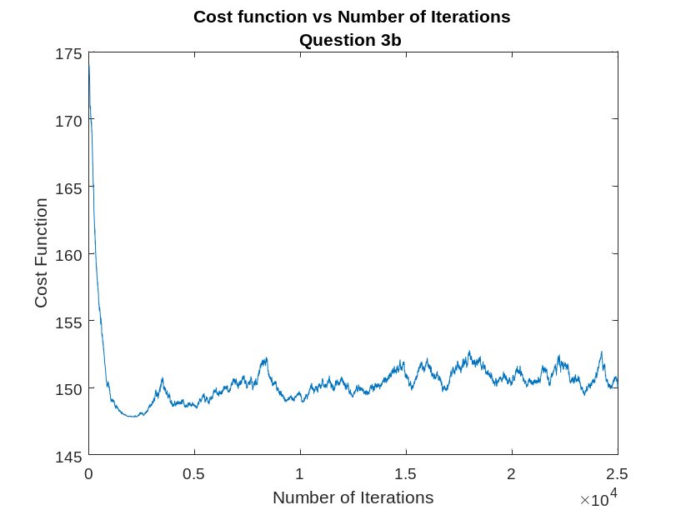
Outputs :

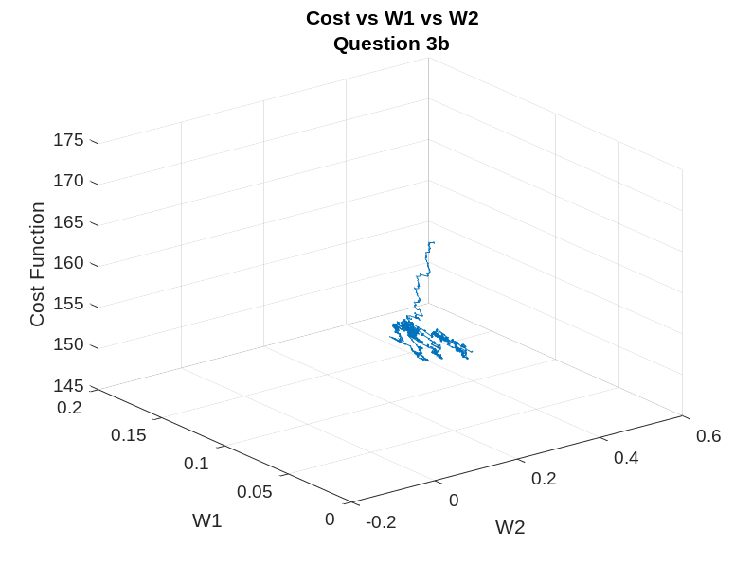

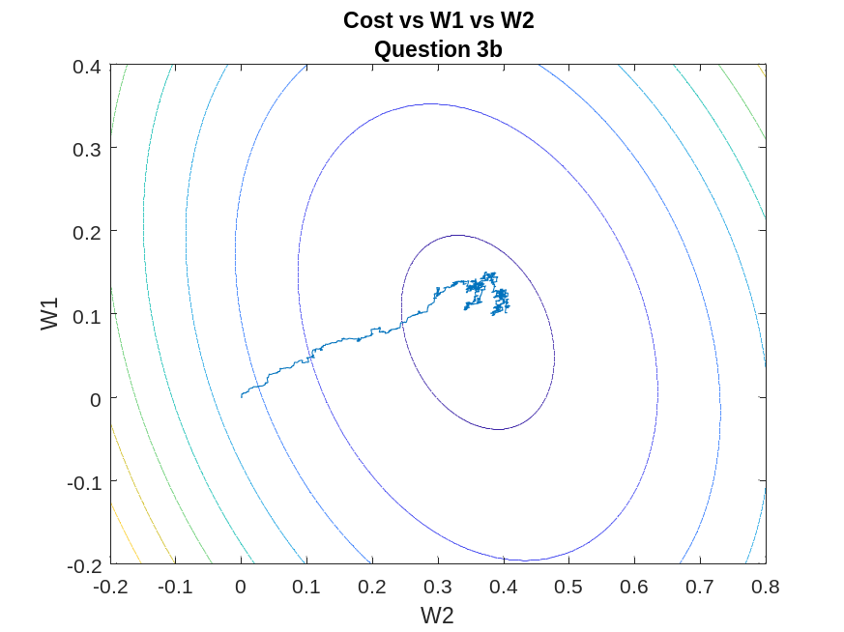

Question 4 – Vectorized Linear Regression

%Preprocessing the data
data = xlsread('data.xlsx');
X = [ones(size(data, 1), 1) data(:, 1:2)];
X(:, 2) = (X(:, 2) - mean(X(:, 2)))/std(X(:, 2));
X(:, 3) = (X(:, 3) - mean(X(:, 3)))/std(X(:, 3));
Y = data(:, 3);
Y = (Y - mean(Y))/std(Y);
w = inv((X')*X)*((X')*Y); %Weight calculation using vectorized linear regression
w_bgd = [0.0000 0.0781 0.3606]; %Weights from batch gradient descent
w_sgd = [-0.0018 0.0905 0.3580]; %Weights from stochastic gradient descent
e1 = sqrt(sum((w’ - w_bgd).^2)); %Error 1 calculation
e2 = sqrt(sum((w’ - w_sgd).^2)); %Error 2 calculation

Final Weights : [0.0000 0.0781 0.3606]
Error 1 : 5.7976e-05
Error 2 : 0.0128

Question 5 – Least Angle Regression – Batch Gradient Descent

%Preprocessing the data
data = xlsread('data.xlsx');
X = [ones(size(data, 1), 1) data(:, 1:2)];
X(:, 2) = (X(:,2) - mean(X(:, 2)))/std(X(:, 2));
X(:, 3) = (X(:, 3) - mean(X(:, 3)))/std(X(:, 3));
Y = data(:, 3);
Y = (Y - mean(Y))/std(Y);
w = [0 0 0]; %Initial Weigths
alpha = 0.001; %Learning rate
lambda = 0.4; %Regularization Parameter
iter_nos = 100;
J = zeros(iter_nos + 1, 1); %Array for cost of each iteration
W = zeros(iter_nos + 1, 2); %Array to store weights after iteration
J(1) = evaluatecostfunction(X, Y, w, lambda);%Initial Cost calculation
W(1, 1) = w(1);
W(1, 2) = w(2);
for i = 1:1:iter_nos
H = X*(w)' - Y; %Hypothesis calculation
for j = 1:1:3
w(j) = w(j) - alpha*(((H')*X(:, j)) - lambda*w(j));
end
J(i+1) = evaluatecostfunction(X, Y, w, lambda);
W(i+1, 1) = w(2);
W(i+1, 2) = w(3);
end
x = 0:1:iter_nos;
plot(x, J);
w1 = 0.4:-0.001:-0.2;
w2 = 0.8:-0.005:-0.2;
J1 = zeros(length(w1), length(w2));
for i = 1:1:length(w1)
for j = 1:1:length(w2)
J1(i, j) = evaluatecostfunction(X, Y, [0 w1(i) w2(j)], lambda);
end
end
figure;
plot3(W(:, 1), J, W(:, 2));
figure;
contour(w2, w1, J1);
hold on;
plot(W(:, 2), W(:, 1));
function J = evaluatecostfunction(X, Y, w, lambda) %Function to calculate the cost function of ridge regression
J = 0;
for i = 1:1:size(X, 1)
J = J + (w*(X(i, :))' - Y(i))^2;
end
J = J + lambda*sum(w.^2);
J = J/2;
end

Final Weights : [-0.0001 0.0776 0.3610]
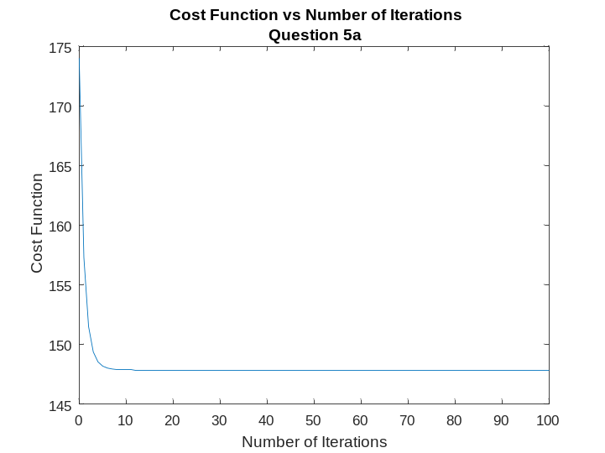
Outputs :

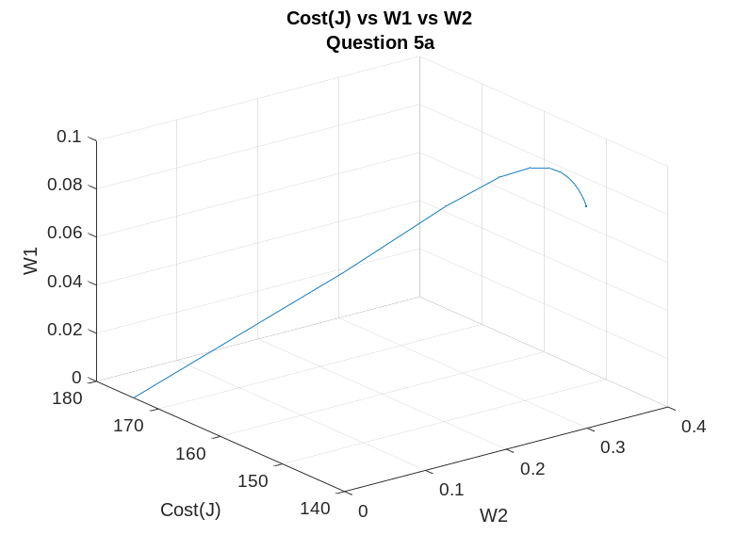

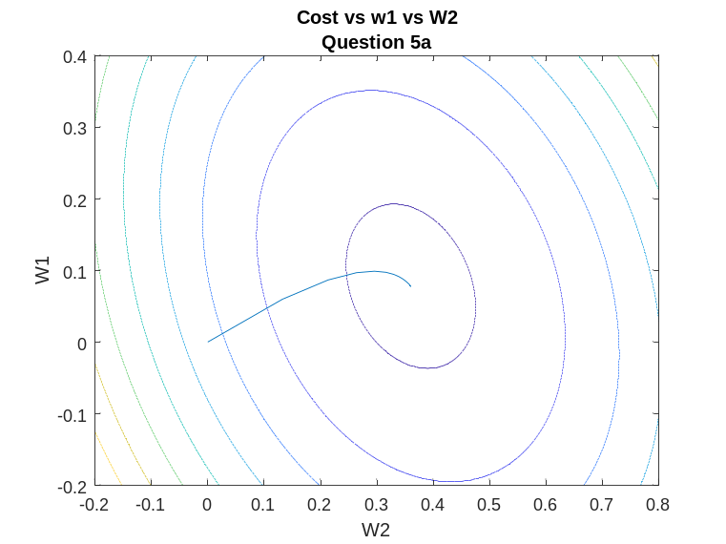

Question 5 – Least Angle Regression – Stochastic Gradient Descent

%Preprocessing the data
data = xlsread('data.xlsx');
X = [ones(size(data, 1), 1) data(:, 1:2)];
X(:, 2) = (X(:, 2) - mean(X(:, 2)))/std(X(:, 2));
X(:, 3) = (X(:, 3) - mean(X(:, 3)))/std(X(:, 3));
Y = data(:, 3);
Y = (Y - mean(Y))/std(Y);
w = [0 0 0]; %Initial Weights
alpha = 0.001; %Learning Rate
lambda = 0.1; % Regularization Paramter
iter_nos = 200;
t_instances = 25; %Number of instances per iteration
J = zeros(iter_nos*t_instances+1, 1); %Array to store cost function after each iteration
W = zeros(iter_nos*t_instances+1, 3); %Array to store weights after each iteration
J(1) = evaluatecostfunction(X, Y, w, lambda);
W(1, 1) = w(1);
W(1, 2) = w(2);
W(1, 3) = w(3);

for i = 1:1:iter_nos
X_new = randperm(size(X,1), t_instances);
for j = 1:1:t_instances
H = (X(X_new(j), :)*(w)' - Y(X_new(j)));
for q = 1:1:3
w(q) = w(q) - alpha*((H')*X(X_new(j), q) - lambda/2*sign(w(q))); %Weight update rule
W((i - 1)*t_instances+j+1, q) = w(q);
end
J((i-1)*t_instances+j+1) = evaluatecostfunction(X, Y, w, lambda); %Cost Function calculation
end
end
x = 0:1:iter_nos*t_instances;
plot(x, J)

w1 = 0.4:-0.001:-0.2;
w2 = 0.8:-0.005:-0.2;
J1 = zeros(length(w1), length(w2));
for i = 1:1:length(w1)
for j = 1:1:length(w2)
J1(i, j) = evaluatecostfunction(X, Y, [0 w1(i) w2(j)], lambda);
end
end
figure;
plot3(W(:, 3), W(:, 2), J)
grid on;
figure;
contour(w2, w1, J1)
hold on;
plot(W(:, 3), W(:, 2))
function J = evaluatecostfunction(X, Y, w, lambda) %Function to calcuclate the cost function
J = 0;
for i = 1:1:size(X, 1)
J = J + (w*(X(i,:)') - Y(i))^2;
end
J = J + lambda*sum(abs(w));
J = J/2;
end
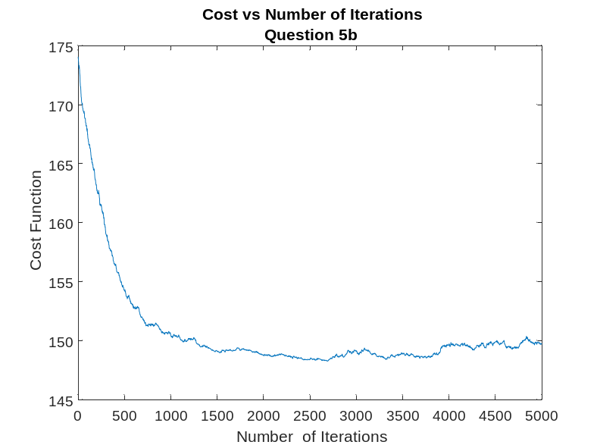
Final Weights : [0.0718 0.1052 0.4273]
Outputs :

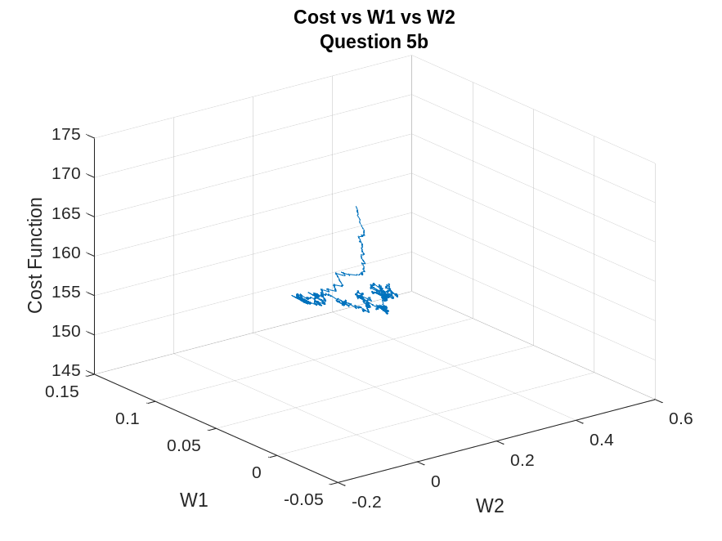

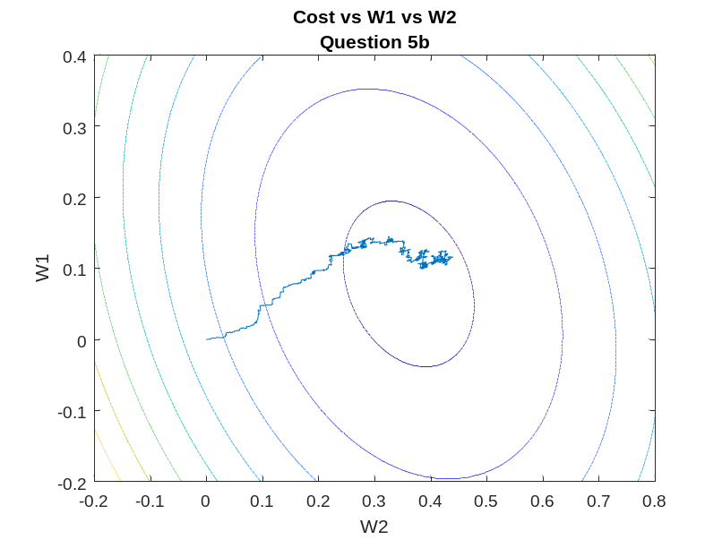

Question 6 – K Means Clustering

%Preprocessing the data
data = xlsread('data2.xlsx');
iter_nos = 100;
cluster_nos = 2;
[c_nos, c] = kmeans(data, cluster_nos, iter_nos);
figure;
scatter(data(:, 1), c); %Class vs Feature 1
hold on;
scatter(c_nos(:, 1), 1:2);
figure;
scatter(data(:, 2), c); %Class vs Feature 2
hold on;
scatter(c_nos(:, 2), 1:2);
figure;
scatter(data(:, 3), c);
hold on;
scatter(c_nos(:, 3), 1:2); %Class vs Feaure 3
figure;
scatter(data(:, 4), c);
hold on;
scatter(c_nos(:, 4), 1:2); % Class vs Feature 4
function [c_center, c] = kmeans(X, cluster_nos, iter_nos)
[rows, cols] = size(X);
c_center = zeros(cluster_nos, cols); %Cluster centers
c = zeros(rows, 1); %Array to assign elemnets to each cluster center
data_num = zeros(cluster_nos, 1); %Array to store elements of the clusters
X_new = randperm(size(X, 1), cluster_nos);
for i = 1:1:cluster_nos
c_center(i,:) = X(X_new(i), :);
end
for i = 1:1:iter_nos
dist = zeros(rows, cluster_nos);
for j = 1:1:rows
for k = 1:1:cluster_nos
dist(j, k) = sqrt(sum((X(j, :) - c_center(k, :)).^2)); %Finding distance between clusters and data points
end
c(j) = find(dist(j,: ) == min(dist(j,: )),1);
end
for k = 1:1:cluster_nos
data_num(k) = sum(c(:) == k);
c_center(k,:) = sum(X(find(c(:) == k),:))/data_num(k); %finding mean of clusters to recalculate cluster centers
end
end
end

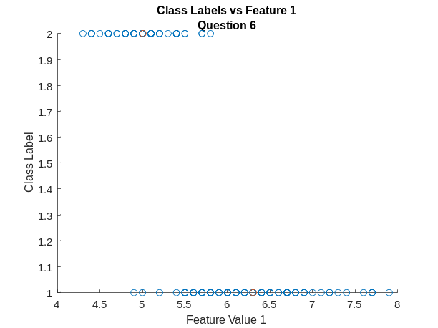

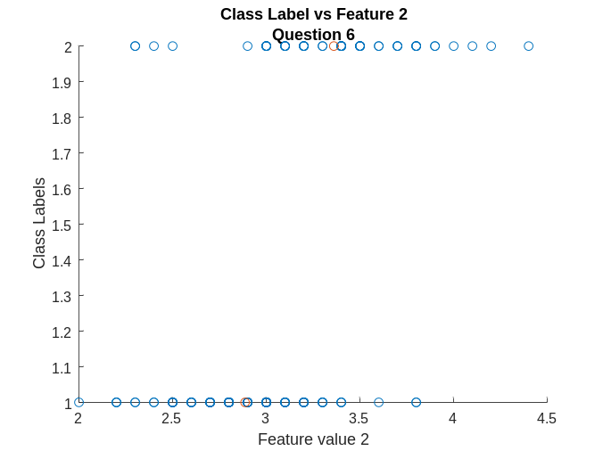

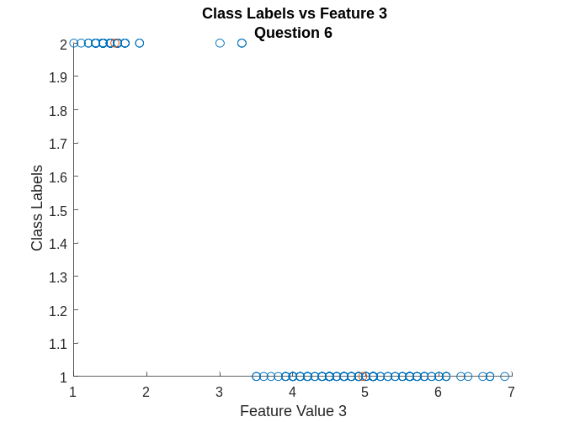

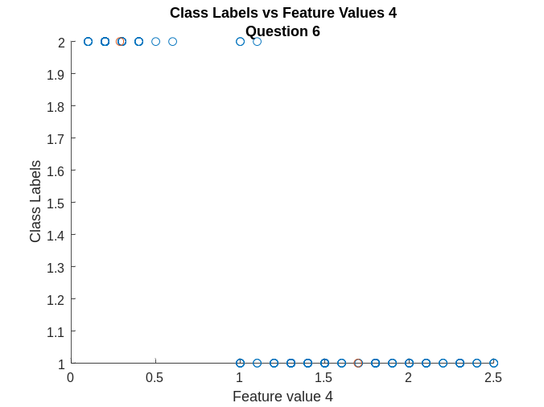

Question 7 – Logistic Regression – Binary Classification

%Preprocessing the data
data = xlsread('data3.xlsx');
data(:, 1:4) = (data(:, 1:4) - mean(data(:, 1:4)))./std(data(:, 1:4));
data(:, 5) = data(:, 5) - 1;
X = randperm(size(data, 1));
train_data = [ones(0.6*size(data, 1), 1) data(X(1:0.6*size(data, 1)), :)];
test_data = [ones(0.4*size(data, 1), 1) data(X(0.6*size(data, 1) + 1:end), :)];
w = zeros(1, size(train_data, 2) - 1); %Weight initialization
alpha = 0.01; %Learning rate
iter_nos = 100;
Y = train_data(:, 6);
for i = 1:1:iter_nos
G = logsig(w*train_data(:,1:5)')'; %Hypothesis calculation
for j = 1:1:size(train_data, 2) - 1
w(j) = w(j) - alpha*sum((Y.*(1-G) + (Y-1).*G).*train_data(:, j)); %Weight update rule
end
end
TP = 0;
TN = 0;
FP = 0;
FN = 0;
P = logsig(w*test_data(:, 1:5)')';
P = 1*(P<0.5);
Y_new = test_data(:, 6);
for i = 1:size(P, 1)
switch (P(i))
case 0
if P(i) == Y_new(i)
TN = TN+1;
else
FN = FN+1;
end
case 1
if P(i) == Y_new(i)
TP = TP + 1;
else
FP = FP + 1;
end
end
end
C_matrix = [TN FP;FN TP]; %Confusion matrix
Sensitivity = TP/(TP + FN); %Sensitivity, Specificity and Accuracy caluclation
Specificity = TN/(TN + FP);
Accuracy = (TN + TP)/(TP + TN + FP + FN);

18 | 0
0 | 22
Confusion Matrix :

Accuracy : 1 Specificity : 1 Sensitivity : 1

Question 8 – Logistic Regression – Multiclass Classification – One vs All

%Preprocessing the data
data = xlsread('data4.xlsx');
data(:, 1:7) = (data(:, 1:7) - mean(data(:, 1:7)))./std(data(:, 1:7));
X = randperm(size(data, 1));
train_data = [zeros(0.6*size(data, 1), 1) data(X(1:0.6*size(data, 1)),:)];
test_data = [zeros(0.4*size(data, 1), 1) data(X(0.6*size(data, 1)+1:end), :)];
iter_nos = 100;
alpha = 0.001; %Learning Rate
t = train_data;
for i = 1:1:90
if train_data(i, 9) == 1
t(i, 9) = 0;
else
t(i, 9) = 1;
end
end
w1 = rand(1, 8); %initializing random weights
Y = t(:, 9);
for i = 1:1:iter_nos
G = logsig(w1*t(:, 1:8)')'; %Hypothesis calculation
for j = 1:1:8
w1(j) = w1(j) - alpha*sum((Y.*(1-G) + (Y-1).*G).*t(:, j)); %Weight update
end
end

t = train_data;
for i = 1:1:90
if train_data(i, 9) == 2
t(i, 9) = 0;
else
t(i, 9) = 1;
end
end
w2 = rand(1, 8);
Y = t(:, 9);
for i = 1:1:iter_nos
G = logsig(w2*t(:, 1:8)')';
for j = 1:1:8
w2(j) = w2(j) - alpha*sum((Y.*(1-G) + (Y-1).*G).*t(:, j));
end
end

t = train_data;
for i = 1:1:90
if train_data(i, 9) == 3
t(i, 9) = 0;
else
t(i, 9) = 1;
end
end
w3 = rand(1, 8);
Y = t(:, 9); %Output values
for i = 1:1:iter_nos
G = logsig(w3*t(:, 1:8)')';
for j = 1:1:8
w3(j) = w3(j) - alpha*sum((Y.*(1-G) + (Y-1).*G).*t(:, j));
end
end
%Testing with test data
P1 = logsig(w1*test_data(:, 1:8)')'; %Predistion of 1 vs 2 vs 3 cyclically
P2 = logsig(w2*test_data(:, 1:8)')';
P3 = logsig(w3*test_data(:, 1:8)')';
P = [P1 P2 P3];
P0 = zeros(size(P1, 1), 1);
for i = 1:1:size(P1, 1)
[~, P0(i)] = max(P(i, :)); %Prediction by maximum probability
end

c = zeros(3);
for i = 1:1:size(P0, 1)
if test_data(i, 9) == 1
c(1, P0(i)) = c(1, P0(i))+1;
elseif test_data(i, 9) == 2
c(2, P0(i)) = c(2, P0(i))+1;
else
c(3, P0(i)) = c(3, P0(i))+1;
end
end
%Confusion matrix and Accuracy determination
IA = zeros(1,3);
OA = 0;
for i = 1:1:3
IA(i) = c(i,i)/sum(c(i, :));
OA = OA + c(i,i);
end
OA = OA/sum(c(:));

Individual Accuracies: [1.0000 0.5000 0.9091]
Final Weights : W1 = [0.5328 -3.9060 5.9889 -5.9128 -5.3727 -3.9507 5.2497 -3.6171]
W2 = [0.2681 5.2898 -2.7312 5.4791 5.4375 3.5252 -2.0258 3.8214]
W3 = [0.7387 6.5984 -2.5721 7.8486 7.1750 6.5093 -1.9777 6.3385]
Overall Accuracy: 0.8000
18 | 0 | 0
4 | 10 | 6
0 | 2 | 20
Confusion Matrix =

Question 8 – Logistic Regression – Multiclass, One vs One

%Preprocessing the data
data = xlsread('data4.xlsx');
data(:, 1:7) = (data(:, 1:7) - mean(data(:, 1:7)))./std(data(:, 1:7));
X = randperm(size(data, 1));
train_data = [ones(0.6*size(data, 1), 1) data(X(1:0.6*size(data, 1)), :)];
test_data = [ones(0.4*size(data, 1) ,1) data(X(0.6*size(data, 1)+1:end), :)];
iter_nos = 500;
alpha = 0.0001;
w1 = zeros(1, 8);
w2 = zeros(1, 8);
w3 = zeros(1, 8);
t = [];
for i = 1:1:90
if train_data(i ,9) == 1
t = [t, train_data(i, 1:8) 0];
elseif train_data(i, 9) == 1
t = [t; train_data(i, 1:8) 1];
end
end
Y = t(:, 9);
for i = 1:1:iter_nos
G = logsig(w1*t(:, 1:8)')';
for j = 1:1:8
w1(j) = w1(j) - alpha*sum((Y.*(1-G) + (Y-1).*G).*t(:, j));
end
end

t = [];
for i = 1:1:90
if train_data(i,9) == 2
t = [t;train_data(i, 1:8) 0];
elseif train_data(i, 9) == 3
t = [t;train_data(i, 1:8) 1];
end
end
Y = t(:, 9);
for i = 1:1:iter_nos
G = logsig(w2*t(:, 1:8)')';
for j = 1:1:8
w2(j) = w2(j) - alpha*sum((Y.*(1-G) + (Y-1).*G).*t(:, j));
end
end

t = [];
for i = 1:1:90
if train_data(i,9) == 3
t = [t;train_data(i, 1:8) 0];
elseif train_data(i, 9) == 1
t = [t;train_data(i, 1:8) 1];
end
end
Y = t(:, 9);
for i = 1:1:iter_nos
G = logsig(w3*t(:, 1:8)')';
for j = 1:1:8
w3(j) = w3(j) - alpha*sum((Y.*(1-G) + (Y-1).*G).*t(:, j));
end
end

P1 = logsig(w1*test_data(:, 1:8)')';
P2 = logsig(w2*test_data(:, 1:8)')';
P3 = logsig(w3*test_data(:, 1:8)')';
Y1 = zeros(size(P1, 1), 1);
for i = 1:1:size(P1, 1)
if P1(i)>0.5
Y1(i) = 2;
else
Y1(i) = 1;
end
end
Y2 = zeros(size(P2, 1), 1);
for i = 1:1:size(P2, 1)
if P2(i) > 0.5
Y2(i) = 2;
else
Y2(i) = 3;
end
end
Y3 = zeros(size(P3, 1), 1);
for i = 1:1:size(P3, 1)
if P3(i) >0.5
Y3(i) = 3;
else
Y3(i) = 1;
end
end
Y = zeros(size(P1, 1), 1);
for i = 1:1:size(Y, 1)
if (Y1(i) + Y2(i) + Y3(i)) ~= 6
Y(i) = mode([P1(i) P2(i) P3(i)]);
else
Y_r = [P1(i) P2(i) P3(i)];
[~, Y(i)] = max(Y_r);
if Y(i) == 1
t = 1;
elseif Y(i) == 2
t = 2;
elseif Y(i) == 3
t = 3;
end
Y(i) = t;
end
end
c = zeros(3);
for i = 1:1:size(Y, 1)
if test_data(i ,9) == 1
c(1, Y(i)) = c(1, Y(i)) + 1;
elseif test_data(i, 9) == 2
c(2, Y(i)) = c(2, Y(i)) + 1;
else
c(3, Y(i)) = c(3, Y(i)) +1;
end
end
IA = zeros(1,3);
OA = 0;
for i = 1:1:3
IA(i) = c(i,i)/sum(c(i, :));
OA = OA + c(i,i);
end
OA = OA/sum(c(:));

Final Weights :
w1 = [-0.1696, 1.323, -1.9694, 2.0518, 1.8129]
w2 = [-0.0102, -0.7664, -0.4933, -0.6896, -0.9024]
w3 = [-0.2294, 2.1184, -1.5275, 2.8904, 2.9472]
Overall Accuracy : 0.8667
Individual Accuracy : [1, 0.5, 1]
20 | 0 | 0
0 | 8 | 8
0 | 0 | 24
Confusion Matrix :

Question 9 – 5 fold cross validation

%Preprocessing the data
X = xlsread('data4.xlsx');
X(:,1:7) = (X(:,1:7)-mean(X(:,1:7)))./std(X(:,1:7)); %Input normalization
p = randperm(size(X,1)); %Shuffling data
k = 600; %Number of iterations
alpha = 0.0001; %Learning rate
K = 5; %5-fold
w1 = rand(K,8); %initial weights for 1 vs all
w2 = rand(K,8); %initial weights for 2 vs all
w3 = rand(K,8); %initial weights for 3 vs all
IA = zeros(K,3); %individual accuracies for 5 folds
OA = zeros(K,1); %overall accuracies for 5 folds
for a=1:K
train_data = [];
%Dividing data using 5-fold approach
for i=1:K
if i+a~=K+1
train_data = [train_data; [ones(0.2*size(X,1),1) ...

X(p(0.2*(i-1)*size(X,1)+1:0.2*i*size(X,1)),:)]];

else
test_data = [ones(0.2*size(X,1),1) ...

X(p(0.2*(i-1)*size(X,1)+1:0.2*i*size(X,1)),:)];

end
end
% 1 vs all classifier
t = train_data;
for i = 1:size(train_data,1)
if train_data(i,9)==1
t(i,9)=0;
else
t(i,9)=1;
end
end
y = t(:,9); %target outputs
for i=1:k
g = logsig(w1(a,:)*t(:,1:8)')'; %hypothesis calculation
%weight updates
for j = 1:size(t,2)-1
w1(a,j) = w1(a,j)-alpha*sum((y.*(1-g)+(y-1).*g).*t(:,j));
end
end
clear y g t i j
% 2 vs all classifier
t = train_data;
for i = 1:size(train_data,1)
if train_data(i,9)==2
t(i,9)=0;
else
t(i,9)=1;
end
end
y = t(:,9); %target outputs
for i=1:k
g = logsig(w2(a,:)*t(:,1:8)')'; %hypothesis calculation
%weight updates
for j = 1:size(t,2)-1
w2(a,j) = w2(a,j)-alpha*sum((y.*(1-g)+(y-1).*g).*t(:,j));
end
end
clear y g t i j
% 3 vs all classifier
t = train_data;
for i = 1:size(train_data,1)
if train_data(i,9)==3
t(i,9)=0;
else
t(i,9)=1;

end
end
y = t(:,9); %target outputs
for i=1:k
g = logsig(w3(a,:)*t(:,1:8)')'; %hypothesis calculation
%weight updates
for j = 1:size(t,2)-1
w3(a,j) = w3(a,j)-alpha*sum((y.*(1-g)+(y-1).*g).*t(:,j));
end
end
clear y g t i j
%Testing using testdata
td = test_data;
yp_1 = logsig(w1(a,:)*td(:,1:8)')'; %prediction of 1 vs 2 and 3
yp_2 = logsig(w2(a,:)*td(:,1:8)')'; %prediction of 2 vs 1 and 3
yp_3 = logsig(w3(a,:)*td(:,1:8)')'; %prediction of 3 vs 1 and 2
u = [yp_1 yp_2 yp_3];
yp = zeros(size(yp_1,1),1);
for i = 1:size(yp_1,1)
%class is determined by the maximum prediction
[~, yp(i)] = max(u(i,:));
end
%Calculating confusion matrix
c = zeros(3);
for i = 1:size(yp,1)
if test_data(i,9) == 1
c(1,yp(i)) = c(1,yp(i))+1;
elseif test_data(i,9) == 2
c(2,yp(i)) = c(2,yp(i))+1;
else
c(3,yp(i)) = c(3,yp(i))+1;
end
end
%Calculating individual and overall accuracies
for i = 1:3
IA(a,i) = c(i,i)/sum(c(i,:));
OA(a) = OA(a) + c(i,i);
end
OA(a) = OA(a)/sum(c(:));
end
OverallAccuracy = mean(OA); %Calculating overall accuracy

First fold : [1.0000 0.5556 1.0000]. OA = 0.9000
Second fold : [1.0000 0.3000 1.0000]. OA = 0.9333
Third Fold : [1.0000 0.6667 1.0000]. OA = 0.7000
Fourth Fold : [1.0000 0.4000 1.0000]. OA = 0.7333
Fifth fold : [1.0000 0.3333 0.8571]. OA = 0.8667

Overall Accuracy : 0.8267

Question 10 – Likelihood Ratio Test

%Preprocessing the data
data = xlsread('data3.xlsx');
data(:, 1:4) = (data(:, 1:4) - mean(data(:, 1:4)))./std(data(:, 1:4));
X = randperm(size(data, 1));
train_data = data(X(1:0.6*size(data, 1)), :);
test_data = data(X(0.6*size(data, 1)+1:end), :);
c1 = []; %Arrays to store data points of each class
c2 = []; %to store probability of being in class 1, 2
p1 = 0;
p2 = 0;
for i = 1:1:size(train_data, 1)
switch train_data(i, 5)
case 1
c1 = [c1; train_data(i, :)];
p1 = p1+1;
case 2
c2 = [c2; train_data(i, :)];
p2 = p2+1;
end
end
p1 = p1/size(train_data, 1); %Probability of the 2 classes
p2 = p2/size(train_data, 1);
c_mean1 = mean(c1(:, 1:4))'; %Mean of the 2 classes
c_mean2 = mean(c2(:, 1:4))';
cov_matrix1 = c1(:, 1:4)'*c1(:, 1:4);%Covariance matrix
det1 = det(cov_matrix1);
cov_matrix2 = c2(:, 1:4)'*c2(:, 1:4);
det2 = det(cov_matrix2);
Y = zeros(size(test_data, 1), 1);
for i = 1:1:size(test_data, 1)
x = test_data(i, 1:4)';
Y1 = ((2*pi)^(-2))*(det1^(-0.5))*exp(-0.5*(x-c_mean1)'*pinv(cov_matrix1)*(x-c_mean1));
Y2 = ((2*pi)^(-2))*(det2^(-0.5))*exp(-0.5*(x-c_mean2)'*pinv(cov_matrix2)*(x-c_mean2));
Y_mat = [Y1/Y2 p2/p1]; %Calculating Liklihood Ratio
[~, Y(i)] = max(Y_mat); %determining class
end
%Calculating confusion matrix
TN = 0;
TP = 0;
FN = 0;
FP = 0;
for i = 1:1:size(Y, 1)
switch Y(i)
case 1
if Y(i) == test_data(i, 5)
TN = TN + 1;
else
FN = FN + 1;
end
case 2
if Y(i) == test_data(i, 5)
TP = TP + 1;
else
FP = FP + 1;
end
end
end
c_matrix = [TN FP; TP FN];
Sensitivity = TP/(TP + FN);
Specificity = TN/(TN + FP);
Accuracy = (TP + TN)/(TP + TN + FP + FN);

19 | 0
0 | 21
Confusion Matrix :

Sensitivity : 1 Specificity : 1 Accuracy : 1

Question 11 - Maximum a posteriori decision rule:

%Preprocessing the data
data = xlsread('data4.xlsx');
data(:, 1:7) = (data(:, 1:7) - mean(data(:, 1:7)))./std(data(:, 1:7));
data = [ones(length(data), 1) data];
X = randperm(length(data));
train_data = data(X(1:0.7*size(data, 1)), :);
test_data = data(X(0.7*size(data, 1) + 1:end), :);
t1 = [];t2 = [];t3 = []; %Diving on the basis of output class
P1 = 0; P2 = 0; P3 = 0;
for i = 1:1:length(train_data)
switch train_data(i, end)
case 1
t1 = [t1; train_data(i, :)];
P1 = P1 + 1;
case 2
t2 = [t2; train_data(i, :)];
P2 = P2 + 1;
case 3
t3 = [t3; train_data(i, :)];
P3 = P3 + 1;
end
end
P1 = P1/size(train_data, 1); %Probability of classes
P2 = P2/size(train_data, 1);
P3 = P3/size(train_data, 1);
mean_t1 = mean(t1(:, 1:8))'; %Calculating means and covariance matrices
mean_t2 = mean(t2(:, 1:8))';
mean_t3 = mean(t3(:, 1:8))';
E1 = t1(:, 1:8)'*t1(:, 1:8);
E2 = t2(:, 1:8)'*t2(:, 1:8);
E3 = t3(:, 1:8)'*t3(:, 1:8);
det_E1 = det(E1); det_E2 = det(E2); det_E3 = det(E3);
Y = zeros(size(test_data, 1));
for i = 1:1:size(test_data, 1)
x = test_data(i, 1:end-1)';
p1 = ((2*pi)^(-2))*det_E1^(-0.5)*exp(-0.5*((x - mean_t1)'/E1)*(x - mean_t1));
p2 = ((2*pi)^(-2))*det_E2^(-0.5)*exp(-0.5*((x - mean_t2)'/E2)*(x - mean_t2));
p3 = ((2*pi)^(-2))*det_E3^(-0.5)*exp(-0.5*((x - mean_t3)'/E3)*(x - mean_t3));
P = [p1*P1 P2*p2 P3*p3]; %calculating P(y/x)
[~, Y(i)] = max([P]); %calculating MAP outputa
end
c = zeros(3); %Calculating the confusion matrix
for i = 1:1:size(Y, 1)
c(test_data(i, end), Y(i)) = c(test_data(i, end), Y(i))+1;
end
IA = zeros(1,3);
OA = 0;
for i = 1:1:3
IA(i) = c(i, i)/sum(c(i, :));
OA = OA + c(i, i);
end
OA = OA/sum(c(:));
Individual Accuracies: [1.0000 1.0000 0.4615]
Net Accuracy : 0.8444
13 | 0 | 0
0 | 16 | 0
0 | 9 | 7
Confusion matrix :

Question 12 – Maximum Likelihood Test

%Preprocessing the data
data = xlsread('data4.xlsx');
data(:, 1:7) = (data(:, 1:7) - mean(data(:, 1:7)))./std(data(:, 1:7));
dataset1 = data(1:50,:);
dataset2 = data(51:100, :);
dataset3 = data(101:end, :);
X = randperm(50);
train_data = [dataset1(X(1:0.7*size(dataset1, 1)), :); dataset2(X(1:0.7*size(dataset2, 1)), :); dataset3(X(1:0.7*size(dataset3, 1)), :)];
test_data = [dataset1(X(0.7*size(dataset1, 1) + 1: end), :); dataset2(X(0.7*size(dataset2, 1) + 1: end), :); dataset3(X(0.7*size(dataset3, 1) + 1:end), :)];
t1 = []; t2 = []; t3 = []; %Diviing classes based on probability
for i = 1:1:size(train_data, 1)
switch train_data(i ,8)
case 1
t1 = [t1; train_data(i, :)];
case 2
t2 = [t2; train_data(i, :)];
case 3
t3 = [t3; train_data(i, :)];
end
end
mean_t1 = mean(t1(:, 1:7))'; %Calculating the mean of 1,2,3
mean_t2 = mean(t2(:, 1:7))';
mean_t3 = mean(t3(:, 1:7))';
E1 = t1(:, 1:7)'*t1(:, 1:7); %Calculating covariance matrix
E2 = t2(:, 1:7)'*t2(:, 1:7);
E3 = t3(:, 1:7)'*t3(:, 1:7);
det_E1 = det(E1);
det_E2 = det(E2);
det_E3 = det(E3);
Y = zeros(size(test_data, 1), 1);
for i = 1:1:size(test_data, 1)
x = test_data(i, 1:7)'; %Calculating P(X/Y)
P1 = ((2*pi)^(-2)*(det_E1^(-0.5))*exp(-0.5*(x-mean_t1)'*pinv(E1)*(x-mean_t1)));
P2 = ((2*pi)^(-2)*(det_E2^(-0.5))*exp(-0.5*(x - mean_t2)'*pinv(E2)*(x - mean_t2)));
P3 = ((2*pi)^(-2)*(det_E3^(-0.5))*exp(-0.5*(x - mean_t3)'*pinv(E3)*(x - mean_t3)));
[~, Y(i)] = max([P1 P2 P3]); %Calculating the ML Output
end
c = zeros(3); %Calculating the confusion matrix
for i = 1:1:size(Y, 1)
if test_data(i, 8) == 1
c(1, Y(i)) = c(1, Y(i)) + 1;
elseif test_data(i, 8) == 2
c(2, Y(i)) = c(2, Y(i)) + 1;
elseif test_data(i, 8) == 3
c(3, Y(i)) = c(3, Y(i)) + 1;
end
end
IA = zeros(1, 3);
OA = 0;
for i = 1:1:3
IA(i) = c(i,i)/sum(c(i, :));
OA = OA + c(i, i);
end
OA = OA/sum(c(:));

Individual Accuracies : [1.0000 1.0000 0.0667]
Overall Accuracy : 0.6889
15 | 0 | 0
0 | 15 | 0
0 | 14 | 1
Confusion Matrix :

Question 13 –
From this assignment, I learned the various logistic and linear regression models and how to implement them using MATLAB. Specifically, the differences between batch and stochastic gradient descent and how regularization improves the performance.
I learnt the difference between supervised and unsupervised learning and the various algorithms to implement the probabilistic models including the ML, MAP classifiers.

